SIMULATION TASK
Name: G R Aakaash Slot: A
Reg No: 192412068 Course faculty: Sathish.K
EXP-1 OUTPUT
QUESTION NO:1 Simulation of LTE throughput performance under varying bandwidth, SNR,
modulation order, coding rate, and user load
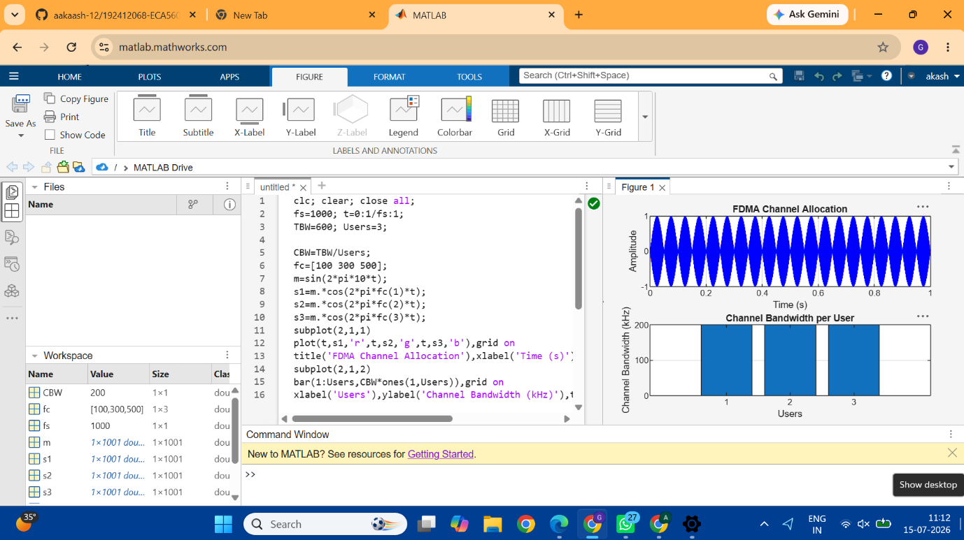
Code: clc; clear; close all;
fs=1000; t=0:1/fs:1;
TBW=600; Users=3;

CBW=TBW/Users;
fc=[100 300 500];
m=sin(2*pi*10*t);
s1=m.*cos(2*pi*fc(1)*t);
s2=m.*cos(2*pi*fc(2)*t);
s3=m.*cos(2*pi*fc(3)*t);
subplot(2,1,1)
plot(t,s1,'r',t,s2,'g',t,s3,'b'),grid on
title('FDMA Channel Allocation'),xlabel('Time (s)'),ylabel('Amplitude')
subplot(2,1,2)
bar(1:Users,CBW*ones(1,Users)),grid on
xlabel('Users'),ylabel('Channel Bandwidth (kHz)'),title('Channel Bandwidth per User')
RESULT: The FDMA system was successfully simulated by allocating separate frequency channels
to three users, and the channel bandwidth assigned to each user was determined.

QUESTION 2: Simulation of LTE protocol stack delay analysis under uplink traffic, downlink traffic,
packet size, retransmission count, and channel quality

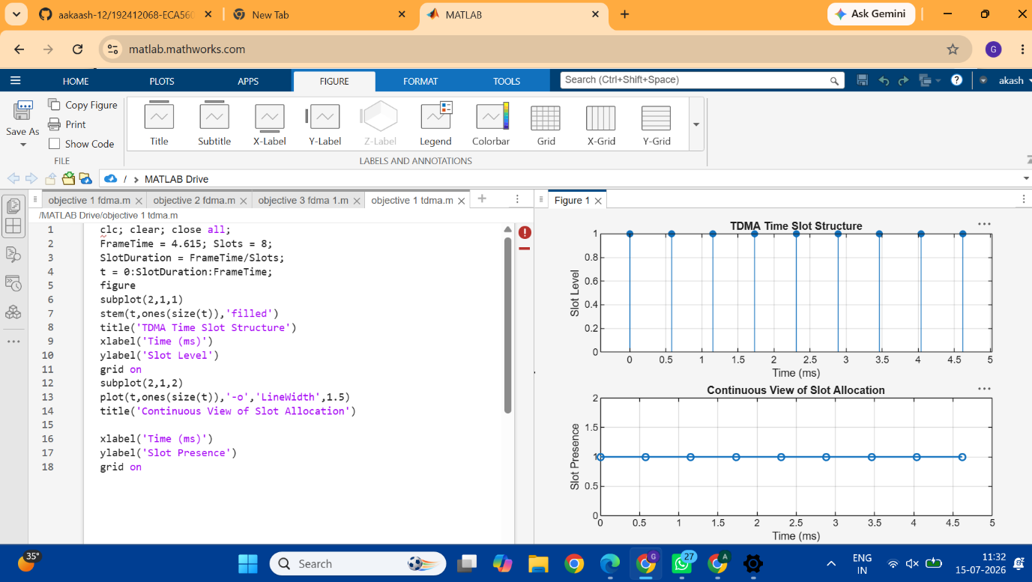
CODE: clc; clear; close all;
FrameTime = 4.615; Slots = 8;
SlotDuration = FrameTime/Slots;
t = 0:SlotDuration:FrameTime;
figure
subplot(2,1,1)
stem(t,ones(size(t)),'filled')
title('TDMA Time Slot Structure')
xlabel('Time (ms)')
ylabel('Slot Level')
grid on
subplot(2,1,2)
plot(t,ones(size(t)),'-o','LineWidth',1.5)
title('Continuous View of Slot Allocation')

xlabel('Time (ms)')
ylabel('Slot Presence')
grid on
RESULT: The time slot duration in the GSM TDMA frame was successfully calculated, confirming
equal division of the frame into fixed time intervals.
QUESTION 3: Simulation of carrier aggregation performance in LTE-Advanced under single carrier,
dual carrier, triple carrier, varying bandwidth, and SNR
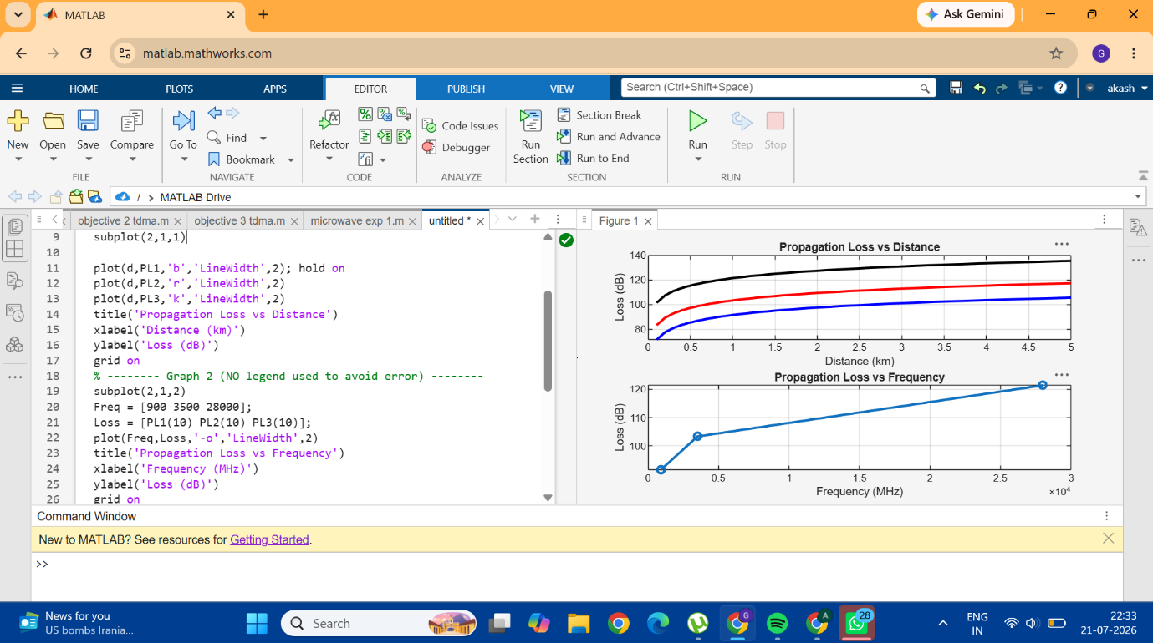
CODE: clc; clear; close all;
d = 0.1:0.1:5; % Distance (km)
f = [900 3500 28000]; % Frequency (MHz)
PL1 = 32.44 + 20*log10(f(1)) + 20*log10(d);
PL2 = 32.44 + 20*log10(f(2)) + 20*log10(d);
PL3 = 32.44 + 20*log10(f(3)) + 20*log10(d);
figure
% -------- Graph 1 --------
subplot(2,1,1)

plot(d,PL1,'b','LineWidth',2); hold on
plot(d,PL2,'r','LineWidth',2)
plot(d,PL3,'k','LineWidth',2)
title('Propagation Loss vs Distance')
xlabel('Distance (km)')
ylabel('Loss (dB)')
grid on
% -------- Graph 2 (NO legend used to avoid error) --------
subplot(2,1,2)
Freq = [900 3500 28000];
Loss = [PL1(10) PL2(10) PL3(10)];
plot(Freq,Loss,'-o','LineWidth',2)
title('Propagation Loss vs Frequency')
xlabel('Frequency (MHz)')
ylabel('Loss (dB)')
grid on
RESULT: The propagation loss was successfully computed for Sub-1 GHz, Mid-band, and
mmWave frequency bands using the Free Space Path Loss (FSPL) model.

QUESTION 4: Simulation of LTE resource block allocation under different user numbers, scheduling
methods, bandwidths, traffic load, and interference levels
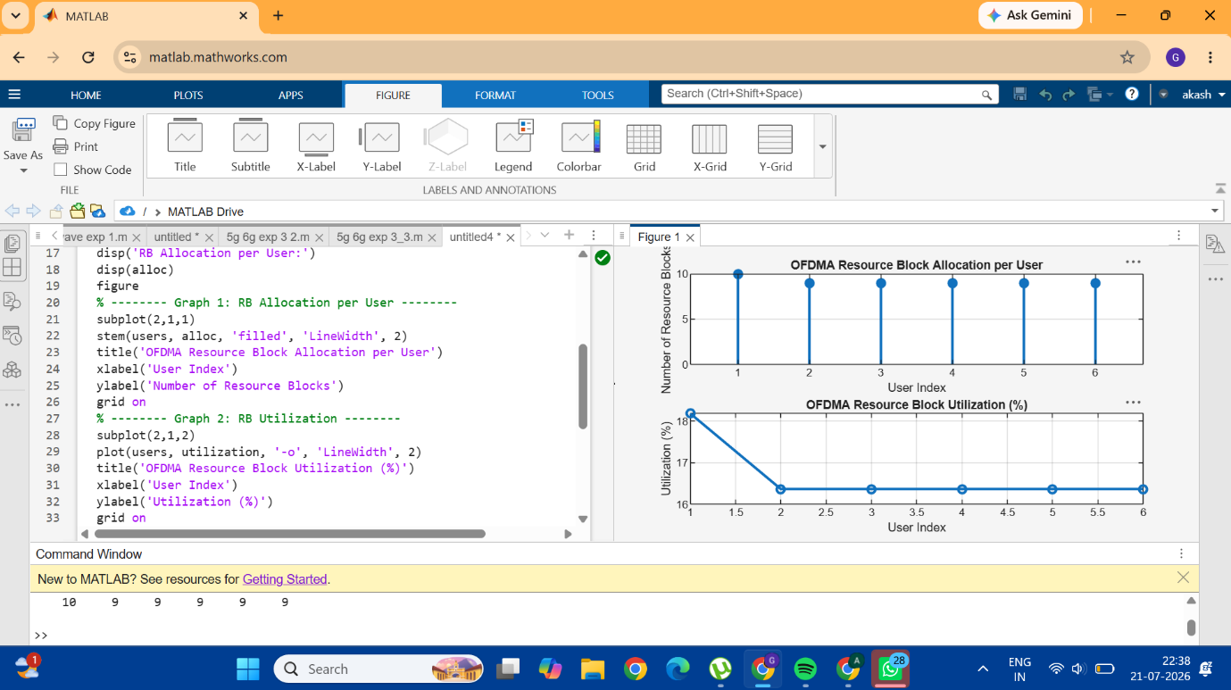
CODE: clc; clear; close all;
% System parameters
bandwidth = 10e6; % 10 MHz
rb_size = 180e3; % 180 kHz per RB
% Total Resource Blocks
total_RB = floor(bandwidth / rb_size);
% Users
users = 1:6;
% RB allocation (simple equal + remainder distribution)
base = floor(total_RB / length(users));

alloc = base * ones(1,length(users));
alloc(1:mod(total_RB,length(users))) = alloc(1:mod(total_RB,length(users))) + 1;
utilization = (alloc / total_RB) * 100;
disp('Total Resource Blocks:')
disp(total_RB)
disp('RB Allocation per User:')
disp(alloc)
figure
% -------- Graph 1: RB Allocation per User --------
subplot(2,1,1)
stem(users, alloc, 'filled', 'LineWidth', 2)
title('OFDMA Resource Block Allocation per User')
xlabel('User Index')
ylabel('Number of Resource Blocks')
grid on
% -------- Graph 2: RB Utilization --------
subplot(2,1,2)
plot(users, utilization, '-o', 'LineWidth', 2)
title('OFDMA Resource Block Utilization (%)')
xlabel('User Index')
ylabel('Utilization (%)')
grid on
RESULT: The Resource Block (RB) allocation was successfully simulated for multiple users in the
OFDMA system, demonstrating how available spectrum is distributed among active
users.
QUESTION 5: Simulation of LTE scheduler performance using Round Robin, Proportional Fair, Max C/I, delay variation, and throughput comparison
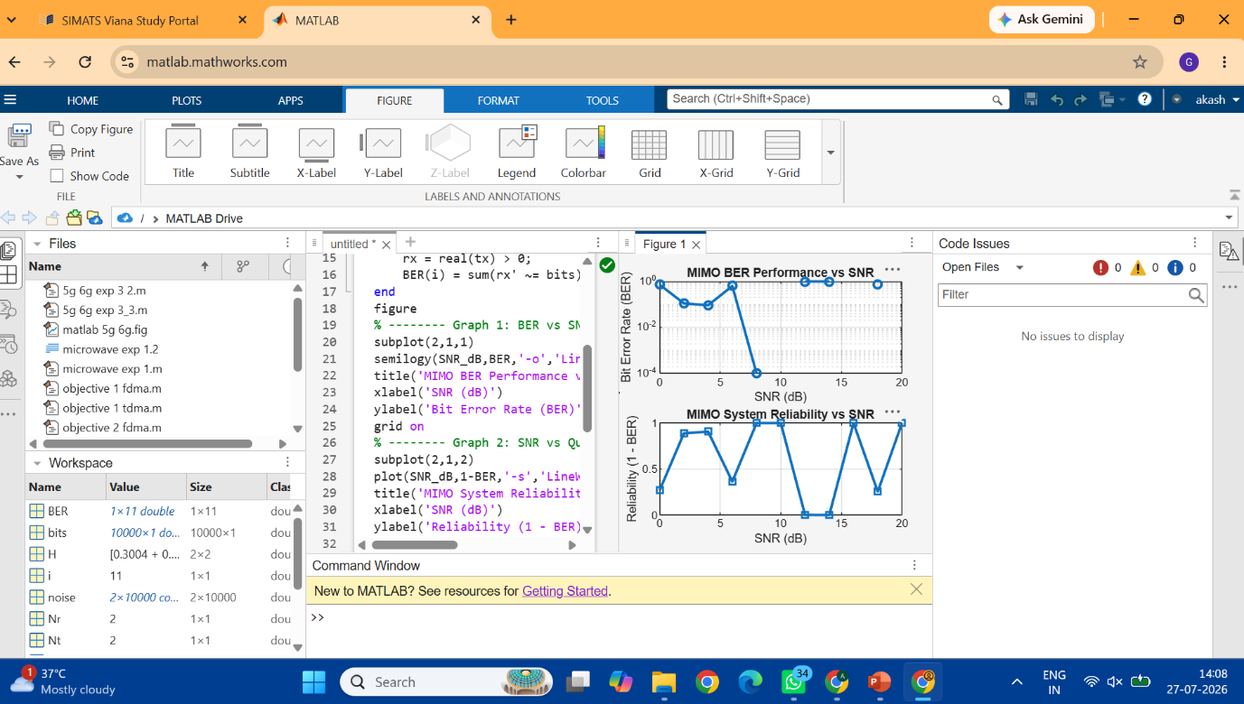

CODE: : clc; clear; close all;
% SNR range
SNR_dB = 0:2:20;
SNR = 10.^(SNR_dB/10);
% MIMO parameters
Nt = 2; Nr = 2;
BER = zeros(1,length(SNR));

for i = 1:length(SNR)
bits = randi([0 1],10000,1);
symbols = 2*bits-1; % BPSK
H = (randn(Nr,Nt) + 1j*randn(Nr,Nt))/sqrt(2);
noise = (randn(Nr,10000) + 1j*randn(Nr,10000))/sqrt(2*SNR(i));
tx = H(1,1)*symbols' + noise(1,:);
rx = real(tx) > 0;
BER(i) = sum(rx' ~= bits)/length(bits);
end
figure
% -------- Graph 1: BER vs SNR --------
subplot(2,1,1)
semilogy(SNR_dB,BER,'-o','LineWidth',2)
title('MIMO BER Performance vs SNR')
xlabel('SNR (dB)')
ylabel('Bit Error Rate (BER)')
grid on
% -------- Graph 2: SNR vs Quality Indicator --------
subplot(2,1,2)
plot(SNR_dB,1-BER,'-s','LineWidth',2)
title('MIMO System Reliability vs SNR')
xlabel('SNR (dB)')
ylabel('Reliability (1 - BER)')
grid on
RESULT: The User Throughput (Mbps) was successfully calculated for different users based on allocated resource blocks and modulation efficiency in the OFDMA system.

